|  |
| --- |
| **SEDCO**  **CVM TEAM**  **C# Windows Form Documentation**  **User Manual**  **Mahdi Suleiman**  **Date: 25th May 2022** |

Table of Contents

Students' Property Right Declaration and Anti-Plagiarism Statement i

Abstract v

Chapter 1: User 1

# Abstract

Survey Question Configurator is a C# Windows Form Application for creating 3 types of questions

1. Smiley Question, where you have to set:
   1. Question Order
   2. Question Text
   3. Number of smiley faces
2. Slider Question, where you have to set:
   1. Question Order
   2. Question Text
   3. Start Value
   4. Start Value Caption
   5. End Value
   6. End Value Caption
3. Stars Question:
   1. Question Order
   2. Question Text
   3. Number of smiley stars.

You can Add, Edit, View and Delete any question.

**Keywords:**

Microsoft, C#, SQL, Windows Form

# Chapter 1: User Manual

**1.1 Introduction**

The main idea of this project is to allow its user to view, add, edit and delete 3 types of the previously mentioned questions.

**1.2 How to use**

* First you have the main dialog. It has multiple controls and buttons, divided into numbered sections as the figure shows below:

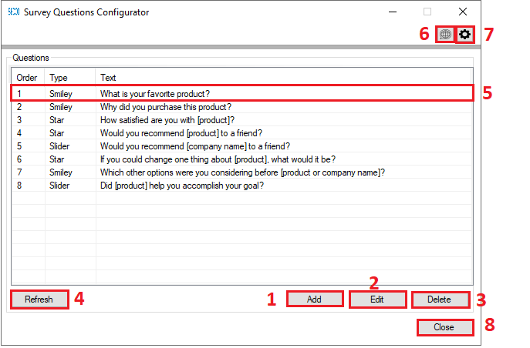

1. Add a question (Opens a new dialog).
2. Edit a **selected** question (Opens a new dialog).
3. Delete a **selected** question (Shows a conformation dialog).
4. Refresh question’s list
5. **Double clicking** a question open it’s **editing** dialog.
6. Changes language settings.
7. Change the connection to a database setting.
8. Close the application.

**1.3 Question Types**

Secondly, if you press “**Add**” you will open “Add A Question” Dialog:

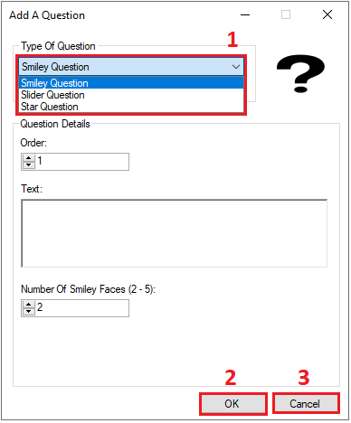

Also divided into 3 section:

1. Continue with your selections and inputs.
2. Add the question.
3. Close the application.

* There are 3 types of questions to add.

1. Smiley faces question

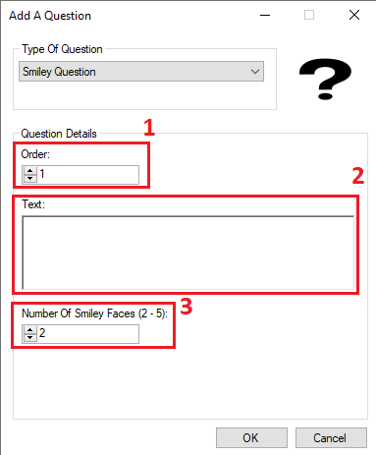

* 1. Order of the question.
  2. Text of the question.
  3. Number of smiley faces (2-5).

*Notes:

1. Questions orders can **NOT** be repeated.
2. Question text can **NOT** be empty nor extend over 4000 character.
3. Number of smiley faces **MUST** be in the range of (2-5) **inclusive**.
4. Slider question

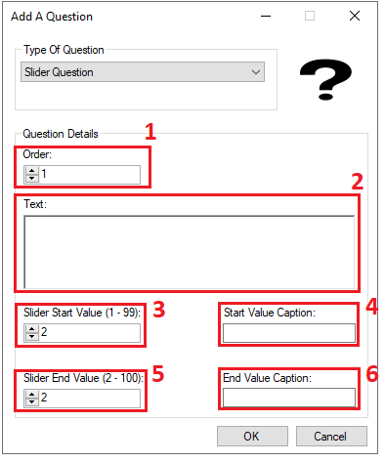

* 1. Order of the question.
  2. Text of the question.
  3. Star value of the slider (1-99) **inclusive**.
  4. Start value caption.
  5. Star value of the slider (2-100) **inclusive**.
  6. Start value caption.

*Notes:

1. Questions orders can **NOT** be repeated.
2. Question text can **NOT** be empty nor extend over 4000 characters.
3. Start value caption and end value caption can **NOT** be empty not extend 100 characters.
4. Start value **MUST** be larger than end value.
5. Stars question

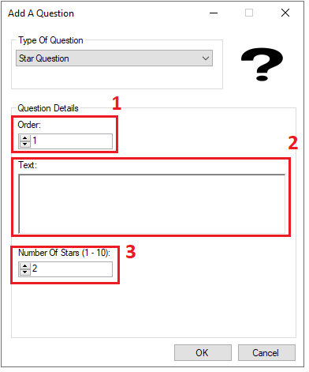

* 1. Order of the question.
  2. Text of the question.
  3. Number of stars (1-10) inclusive.

*Notes:

1. Questions orders can **NOT** be repeated.
2. Question text can **NOT** be empty nor extend over 4000 characters.
3. Number of stars **MUST** be in the range of (1-10) **inclusive**.

**1.4 Editing a question**

By selecting a question and pressing edit, or doubling clicking a question.

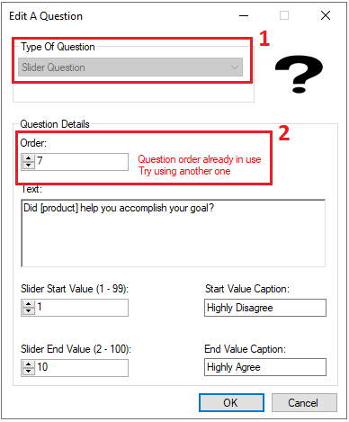

*Notes:

1. Questions type is **locked** to the type of current question type.
2. An error will appear if you try to edit the question with an already **taken** order.

**1.5 Deleting a question**

By selecting a question and pressing delete button.

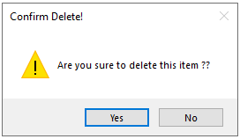

*Notes:

1. Pressing yes will delete the question.

**1.6 Language settings**

When pressing language settings button, a new appears to change the language of the application as shown in the figure below.

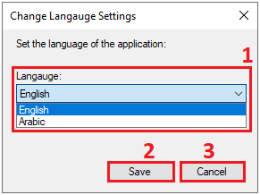

1. Chose the preferred language of the application.
2. Save settings.
3. Close the dialog without saving any settings.

*Notes:

1. Changing the language will cause the application to **restart**.

**1.7 Language settings**

When pressing language settings button, a new appears to change the language of the application as shown in the figure below.

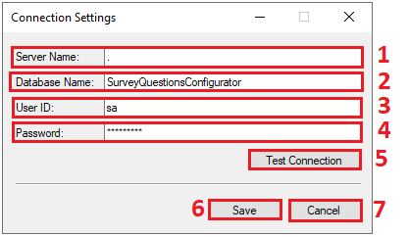

1. Enter the name of the server you want to connect to.
2. Enter the name of the database you want to connect to.
3. Enter the ID of database user.
4. Enter the password of that same user.
5. Test and check the connection of the entered data.
6. Save your settings.
7. Close without saving any settings.

*Notes:

1. Testing connection settings may cause the application to hang for a short time, which is a normal behavior.
2. Saving settings that their connection test failed will make the application go offline until the connection is fixed, and it may hang for a short period of time.